

**Lab 6**

**Reporter：Hu Jiahao**

**Student ID：11612314**

**DataStructureAndAlgorithmAnalysis**

Code:

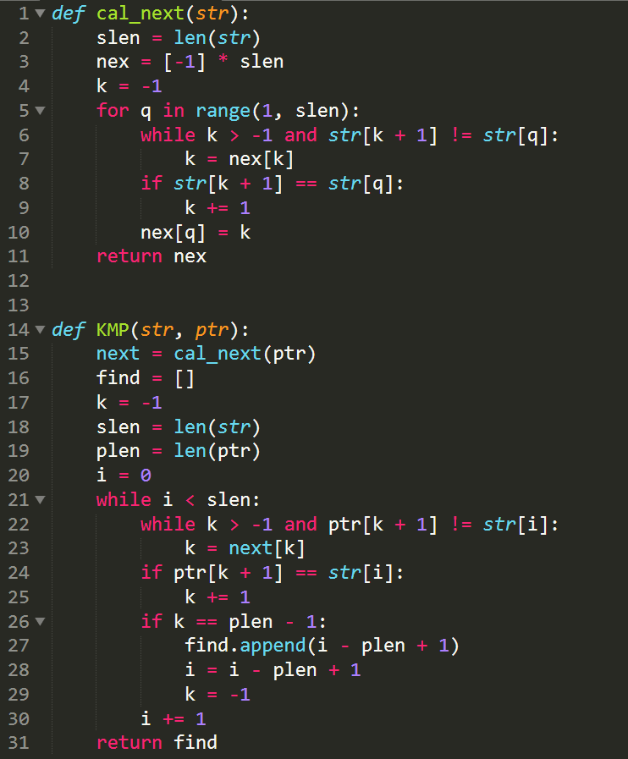

Test:

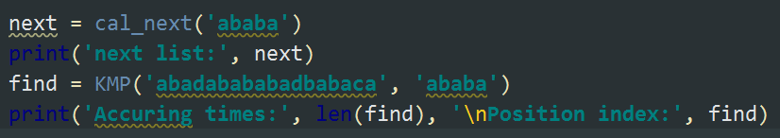

Result:

